**VIHAINEN**

**[](https://www.google.fi/url?sa=i&rct=j&q=&esrc=s&source=images&cd=&cad=rja&uact=8&ved=0ahUKEwjPnZeG_KPWAhWld5oKHc-zDegQjRwIBw&url=https://emojiisland.com/products/very-angry-emoji-icon&psig=AFQjCNHZcPIs7-jINwDffChOQ7a4Z3NrrQ&ust=1505454192230900)**

**TURHAUTUNUT**

[](http://www.google.fi/url?sa=i&rct=j&q=&esrc=s&source=images&cd=&cad=rja&uact=8&ved=0ahUKEwi2up6p_aPWAhWiCJoKHZZyDuYQjRwIBw&url=http://metromode.se/noje/11-emojis-du-anvant-helt-fel-det-har-betyder-de-egentligen/&psig=AFQjCNG5c1x6dAoykMORcblLgJy2B3zAcw&ust=1505454536026782)

[](http://www.google.fi/url?sa=i&rct=j&q=&esrc=s&source=images&cd=&cad=rja&uact=8&ved=0ahUKEwirqb_6_KPWAhWBYJoKHXioBekQjRwIBw&url=http://metromode.se/noje/11-emojis-du-anvant-helt-fel-det-har-betyder-de-egentligen/&psig=AFQjCNER5FSIoPmY26vN6OMzp_0_7p0W4A&ust=1505454438743362)**SURULLINEN**

**VÄSYNYT**

[](http://www.google.fi/url?sa=i&rct=j&q=&esrc=s&source=images&cd=&cad=rja&uact=8&ved=0ahUKEwi7spSM_aPWAhWlNpoKHS3aCe8QjRwIBw&url=http://www.cafe.se/olika-lajks/2/&psig=AFQjCNHsJXJFb6CZp56x4pJoBfiH_X3G_Q&ust=1505454475245681)

[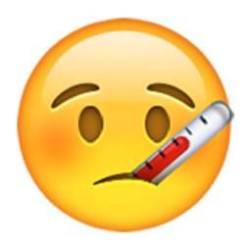](http://www.google.fi/url?sa=i&rct=j&q=&esrc=s&source=images&cd=&cad=rja&uact=8&ved=0ahUKEwjN1Kid_6PWAhVGD5oKHWnzD-QQjRwIBw&url=http://blogs.nottingham.ac.uk/studentlife/2017/03/27/university-life-according-emojis/&psig=AFQjCNHi0IInPSB7yTqO3xndrL0aZPZzjg&ust=1505455042014097) **SAIRAS**

**HÄMMÄSTYNYT**



**KIIREINEN**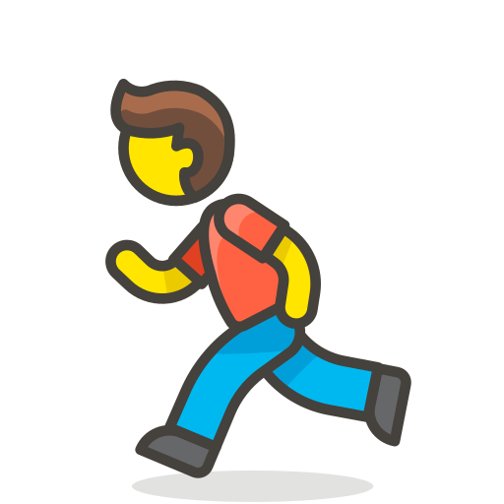

**POHDISKELEVA**

**PYÖRÄLLÄ PÄÄSTÄÄN**

**OK**

[](http://www.google.fi/url?sa=i&rct=j&q=&esrc=s&source=images&cd=&cad=rja&uact=8&ved=0ahUKEwjm9r_V_aPWAhXFC5oKHTgWC-wQjRwIBw&url=http://www.makeuseof.com/tag/emoji-english-dictionary-emoji-faces-meaning-explained/&psig=AFQjCNGlwrM6gUtgNCnUZQl-63DLWhuWgg&ust=1505454592156344)

**TYYTYVÄINEN**

[](http://www.google.fi/url?sa=i&rct=j&q=&esrc=s&source=images&cd=&cad=rja&uact=8&ved=0ahUKEwjarvH-_aPWAhVqIpoKHYogBuUQjRwIBw&url=http://www.cafe.se/snart-slapps-det-250-nya-emoji-symboler-och-varlden-som-vi-kanner-den-kommer-andras-for-alltid-glad-gubbe-tummen-upp/&psig=AFQjCNHbSRckxvRuPYrtT9oaq0dTEniLPA&ust=1505454715617919)

**ILOINEN**

[](http://www.google.fi/url?sa=i&rct=j&q=&esrc=s&source=images&cd=&cad=rja&uact=8&ved=0ahUKEwirt4ya_qPWAhVCCpoKHXIODekQjRwIBw&url=http://www.businessinsider.com/president-obama-is-glad-he-didnt-get-emoji-for-fathers-day-2014-6&psig=AFQjCNHbSRckxvRuPYrtT9oaq0dTEniLPA&ust=1505454715617919)

**ONNELLINEN**

[](http://www.google.fi/url?sa=i&rct=j&q=&esrc=s&source=images&cd=&cad=rja&uact=8&ved=0ahUKEwizm_j7_qPWAhVCYZoKHRrvBPEQjRwIBw&url=http://faze.ca/emoji-study-canadians-love-poop-americans-lipstick-and-spanish-party/&psig=AFQjCNEc7rWfrW3FTX5XcqwTBn35_gJ23Q&ust=1505454977920098)

**JUHLA-**

**TUULELLA**



**HUVITTUNUT**

**KUJEILEVA**

**VOIMISSAAN**



